Unit Name: Unit 2 GitHub for Python
Assessment Name: Lesson 2 Repository, Commits and CLI
Tutor/Assessor Name: Mohammad Ali Afgan
Date:15/06/2026
How to use this document…
The reference column is to be used for the assessment question number/AC, or just to label your screenshots.
Paste your screenshot into the screenshot column.
Ensure each screenshot has an annotation to…
- Offer clarity - draw attention to specific elements in a screenshot i.e. what are you showing us?
- Provide emphasis – point out the important parts of the screenshot i.e. showing that you have undertaken something specific.
- Give context – for contextual information that explains the purpose or highlights specific areas.
Reference | Screenshot
Create a remote repository (2.1) | I had already created a GitHub account here which is located here:  https://github.com/michael-dgidc  Also most of this work is here:  https://github.com/michael-dgidc/CommitsForVersionControl/commits/main/  I logged into the account, selected the Repositories tab, and clicked the green New button to create a new repository. I then completed the setup options shown below, choosing to make the repository public, configure it for Python development, and include a Python .gitignore file.  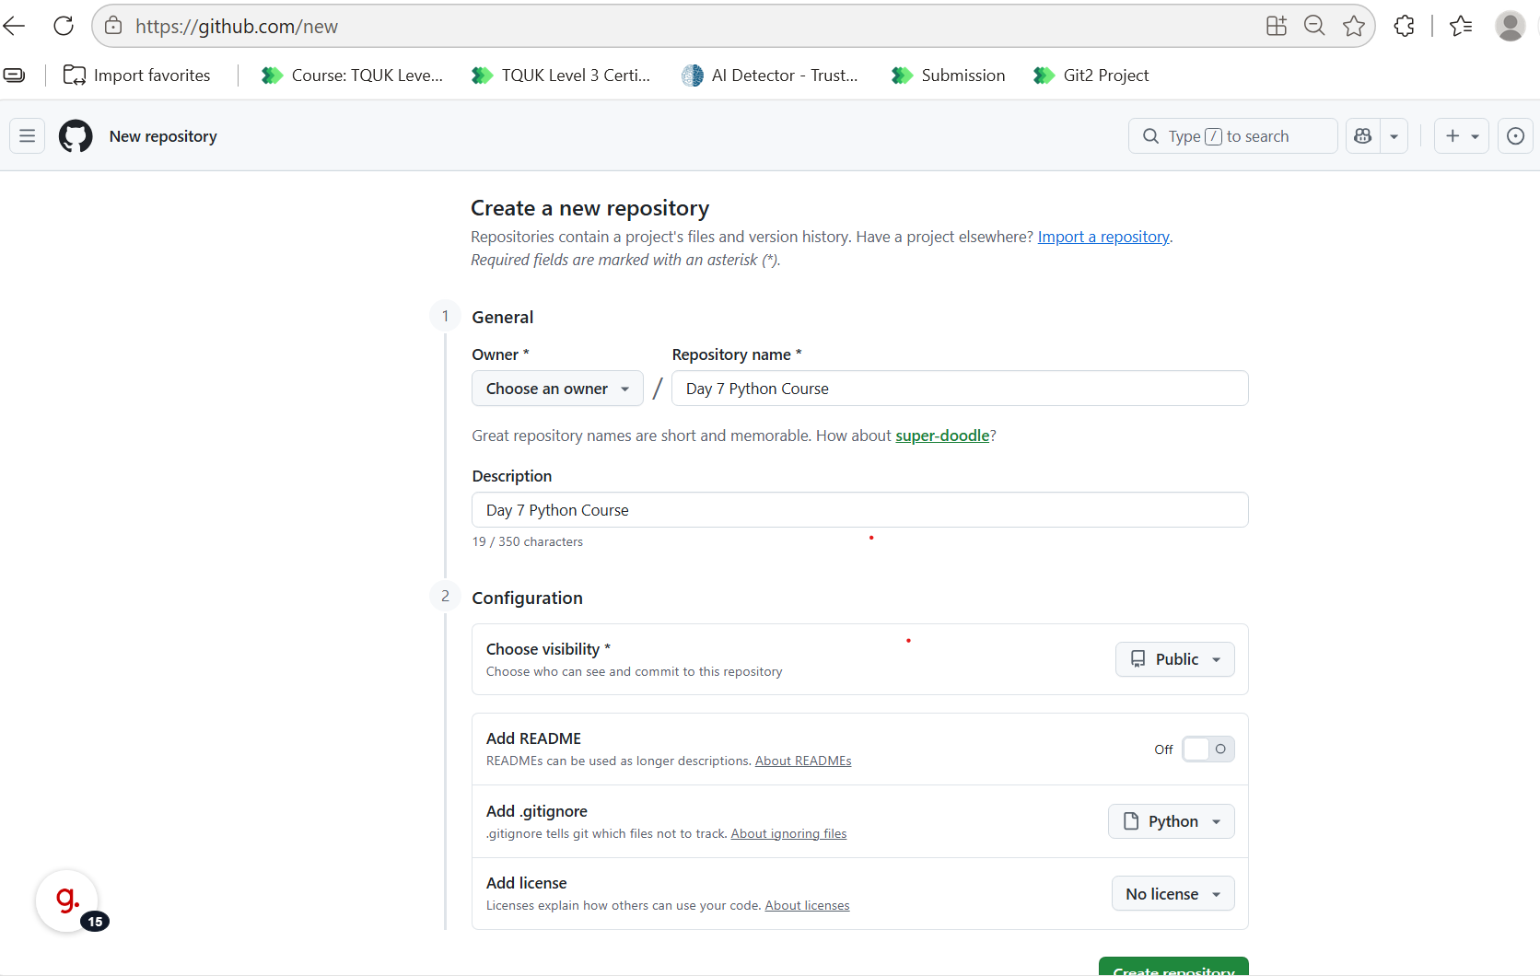  The newly created repo created can now be found at link below:  michael-dgidc/Day-7-Python-Course: Day 7 Python Course  And (in Portal) it looks like this :  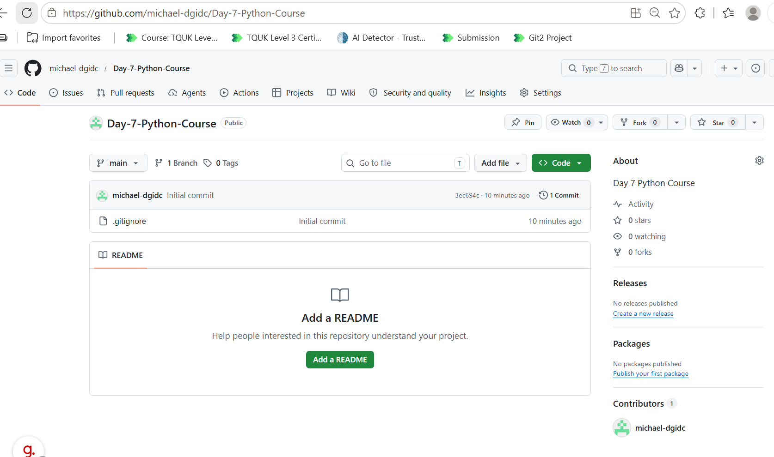  Additionally (after a sync) this became available in GIThub desktop as below:  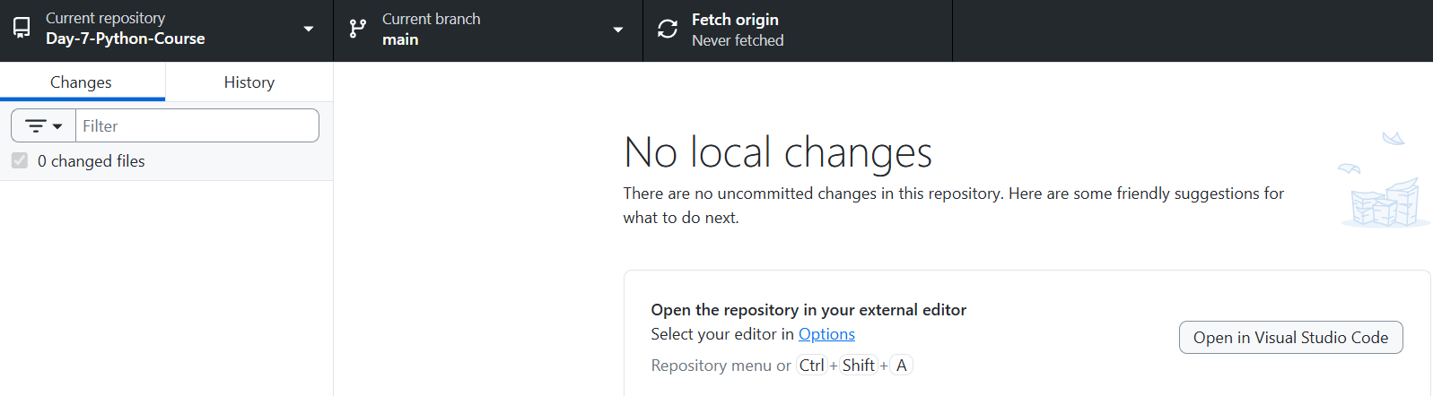
Fork a remote Repo  (2.2) | I have started from an interesting local public repo for a word game located here:  RUDRA212003/scramble_word_game: This is a Scramble Word Game built using the Pygame module in Python. The game challenges the player to unscramble a series of shuffled words within a given time limit. It's a simple yet engaging game designed to improve vocabulary and problem-solving skills  I click the Fork option as below 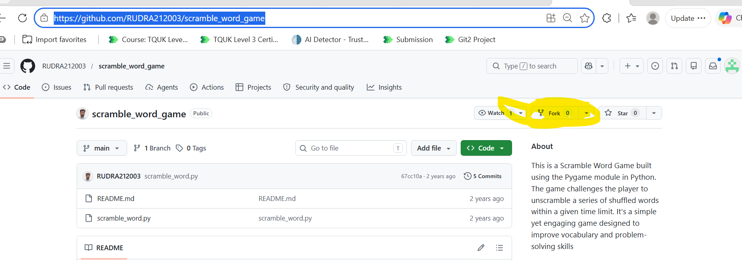  I then give the fork a new ‘Michael name’ and a new public fork is created  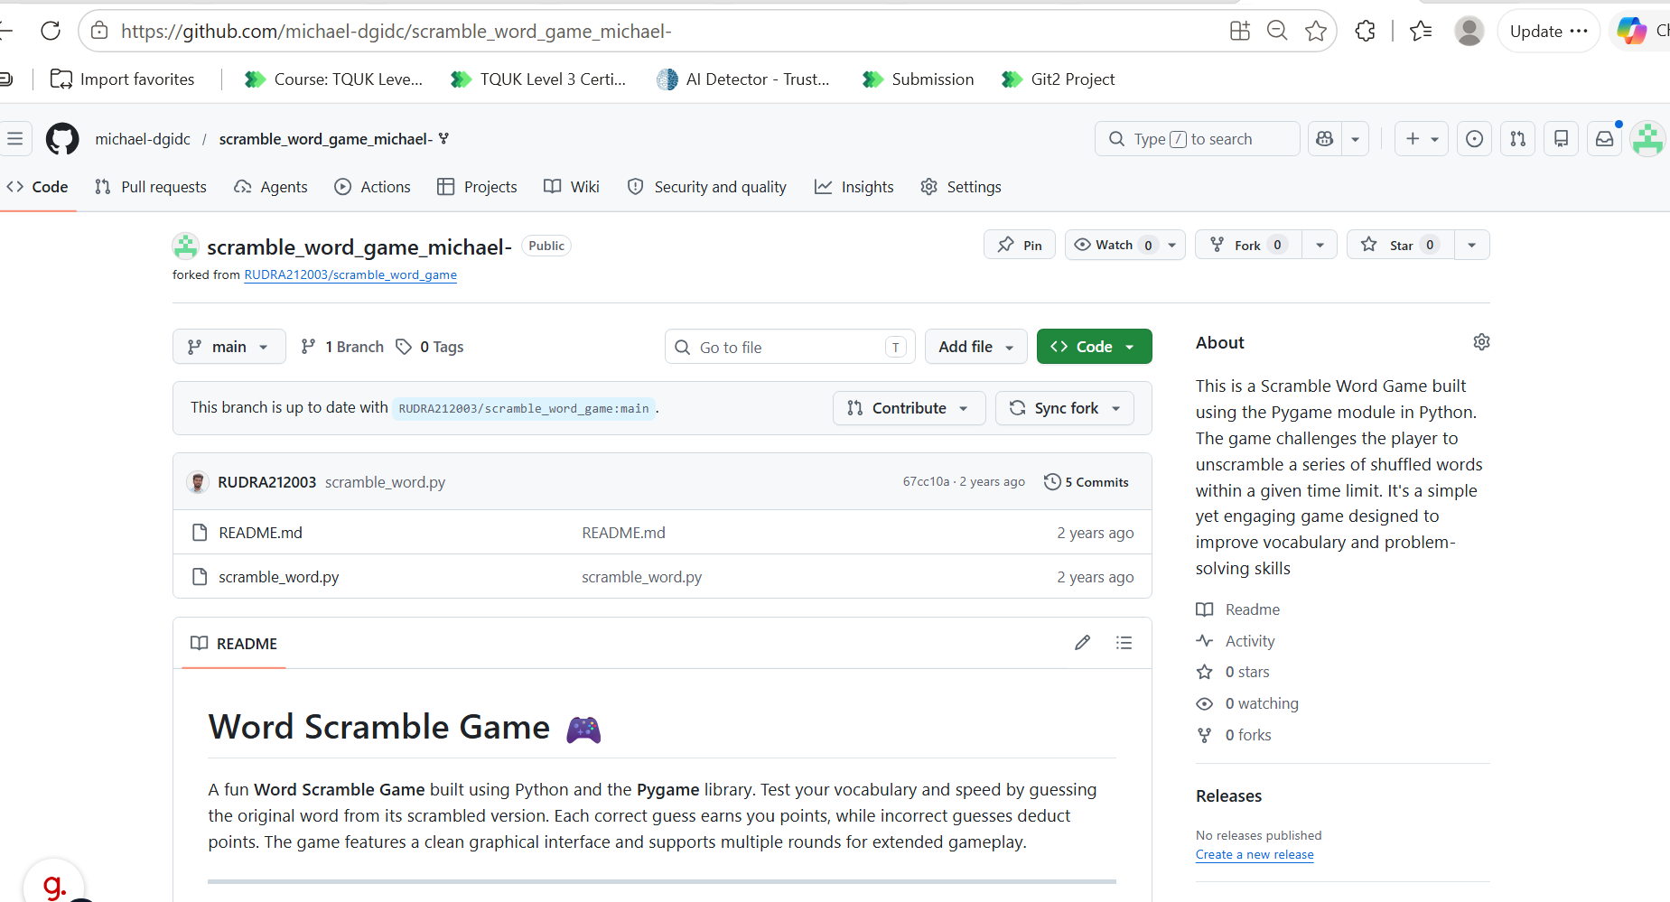  This can be found here:  michael-dgidc/scramble_word_game_michael-: This is a Scramble Word Game built using the Pygame module in Python. The game challenges the player to unscramble a series of shuffled words within a given time limit. It's a simple yet engaging game designed to improve vocabulary and problem-solving skills  This game is then available in my IDE as below:  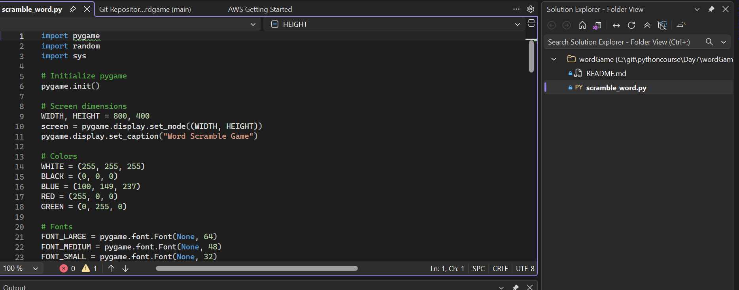  I then ran the prompt pip install pygame  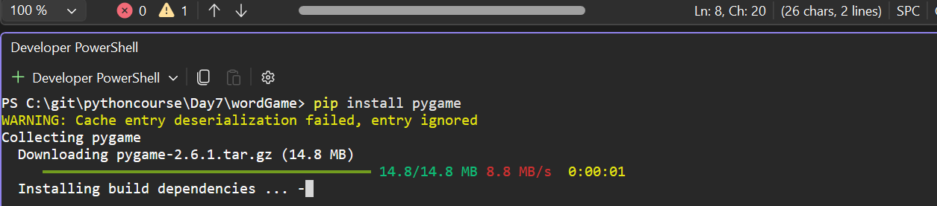
2.3 Demonstrate the use of commits for version control. | I created a new repo for this task:  michael-dgidc/CommitsForVersionControl: Commits For Version Control  I cloned it locally in GIThub desktop as below 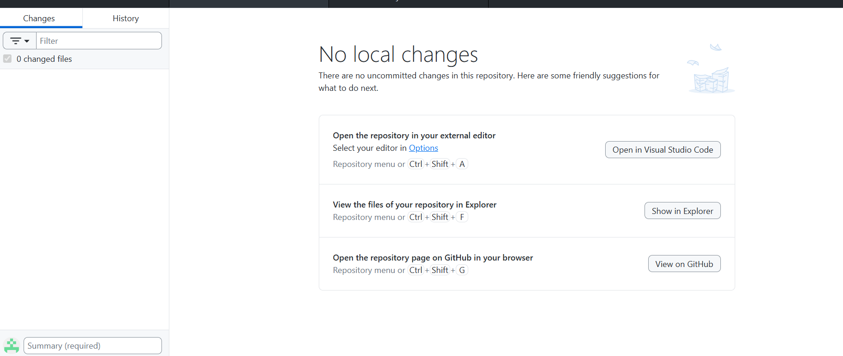
I then added a simple Python Hello World File and then committed that change with a named commit as below:

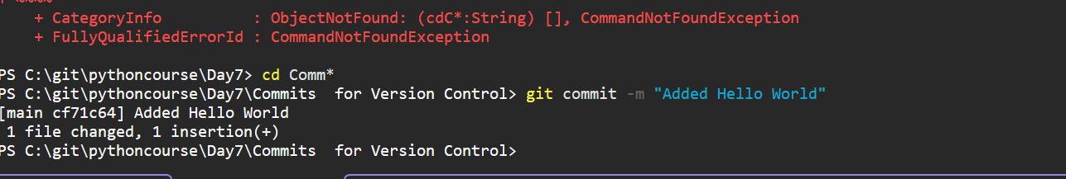

Labelled as Added Hello World

NextI am going to refactor. In this case simple add some annotation (show below):
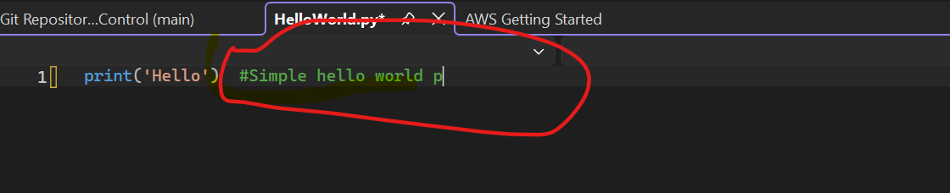

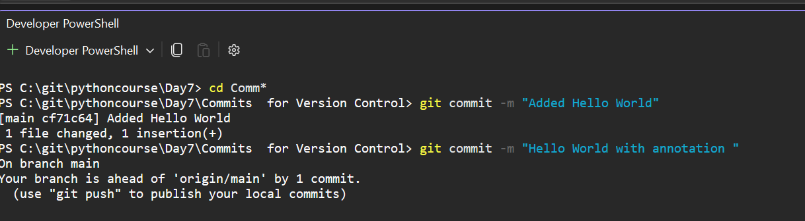

All changes are now in the history (shown by GIT Log)

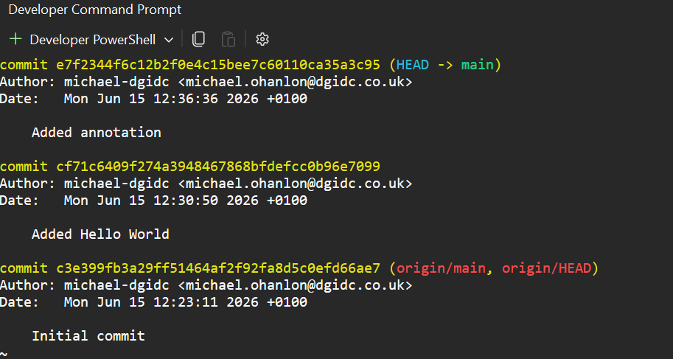

This can also be seen in Desktop tool as below

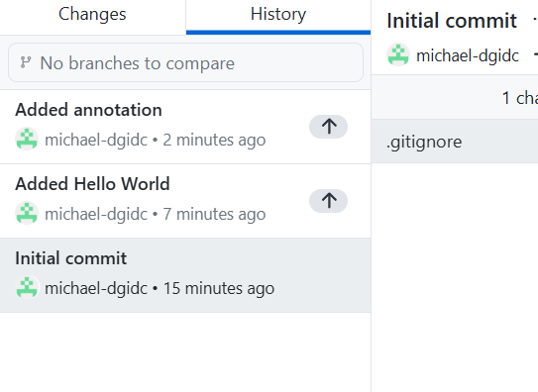

GIT Push | Previous changes are then pushed back to ‘Mother Ship’ using GIT PUSH  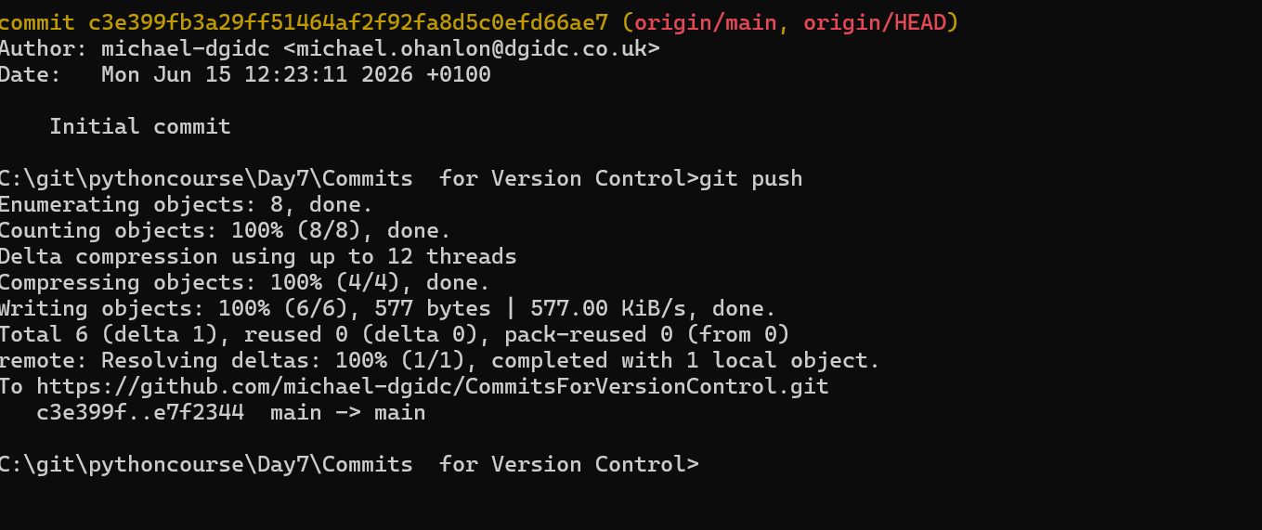  They are then persisted and visible in the Web Portal  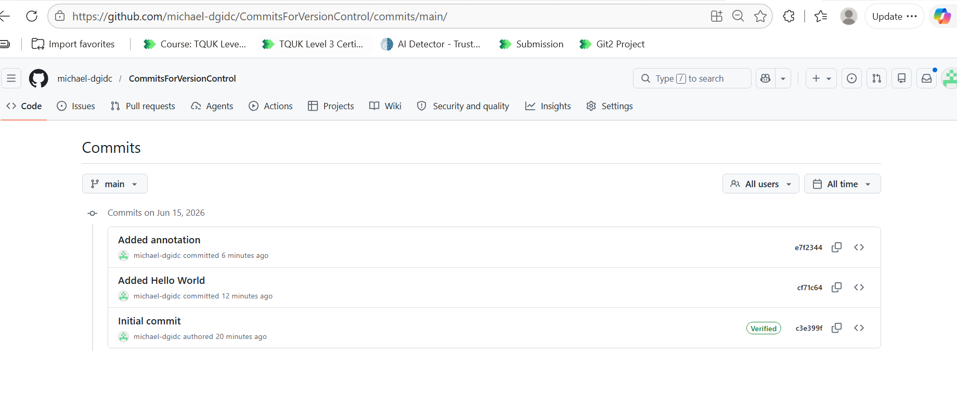
Delete Commit | Using the command line I verify I can switch between commits as below  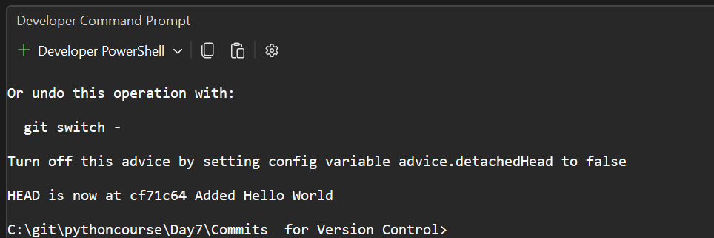
I then check out the annotation branch
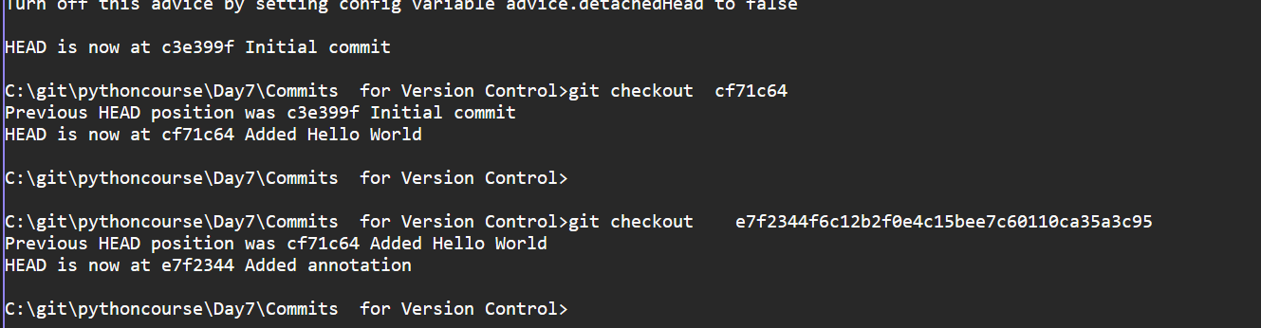
I change the annotation 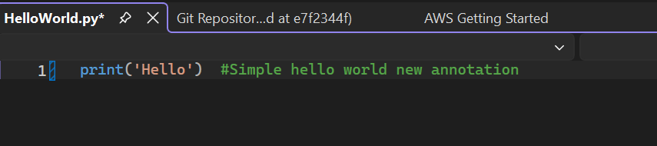

And commit and push

Next I added a new file Hello World Cup and push back to Github
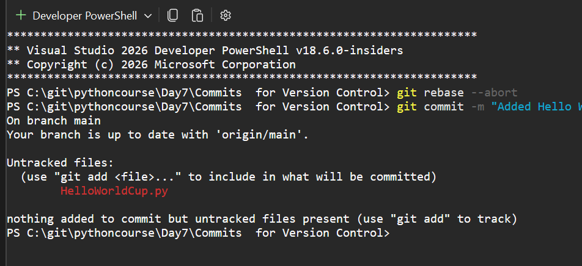

I then remove that commit from history and push back 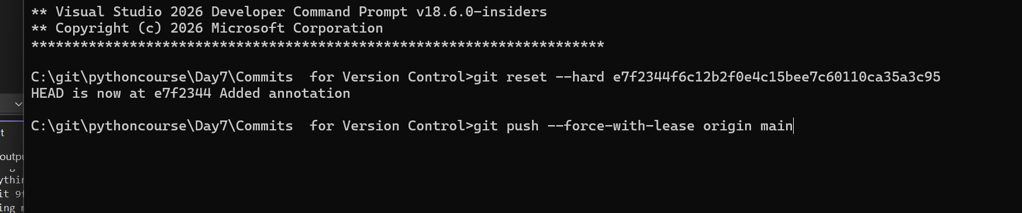
And can see that commit is no longer in code base and also removed from history.
Verify remote using GitHub | At this point I successfully verify the remote repo using the command line:  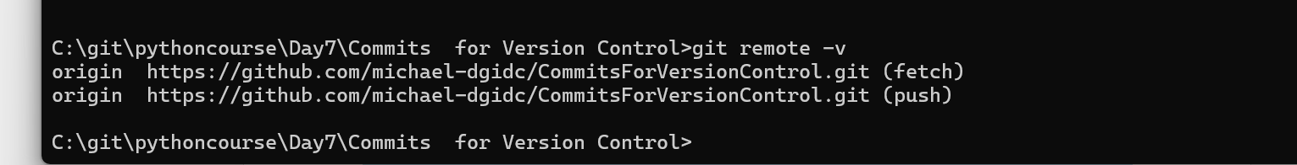
Clone a remote repo | I simply can the command line clone in my day 7 folder  git clone https://github.com/grantjenks/free-python-games.git  This dragged down all of the content locally as below:  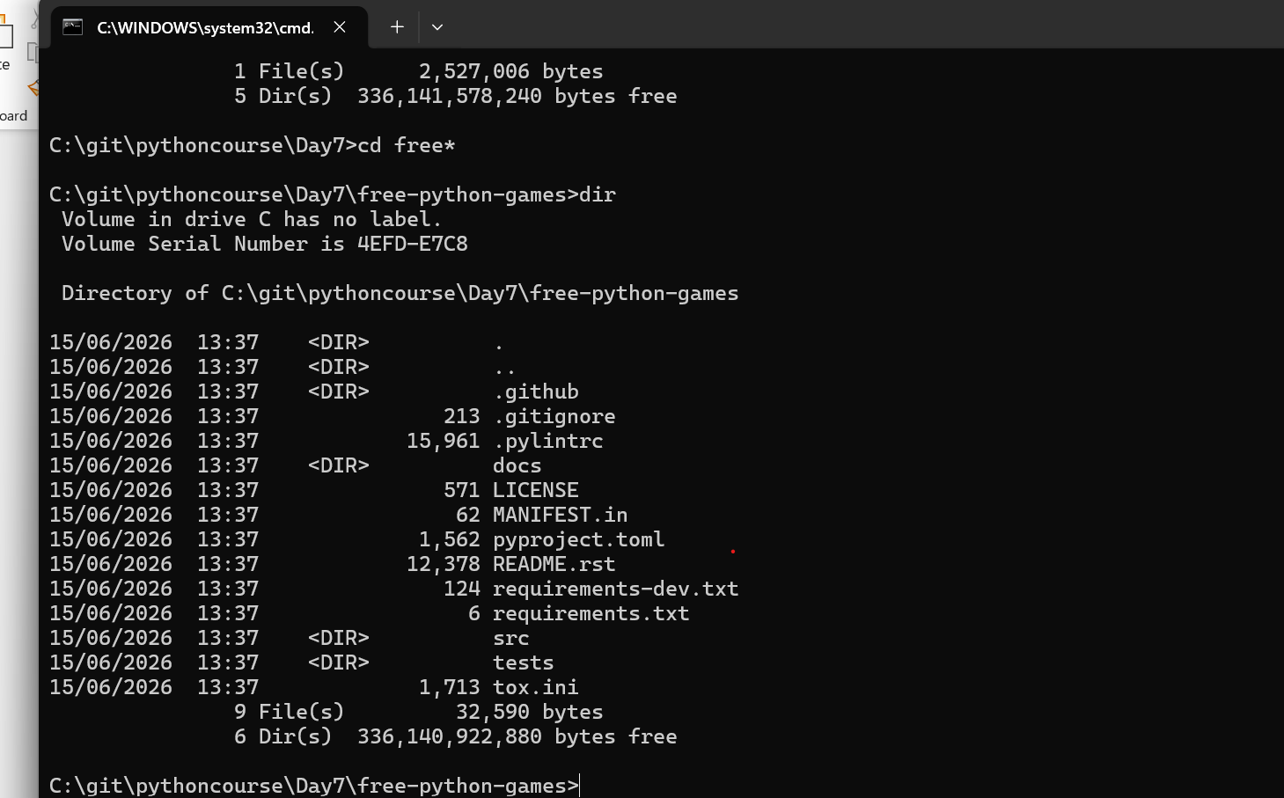
Pong them runs great! As shown below.

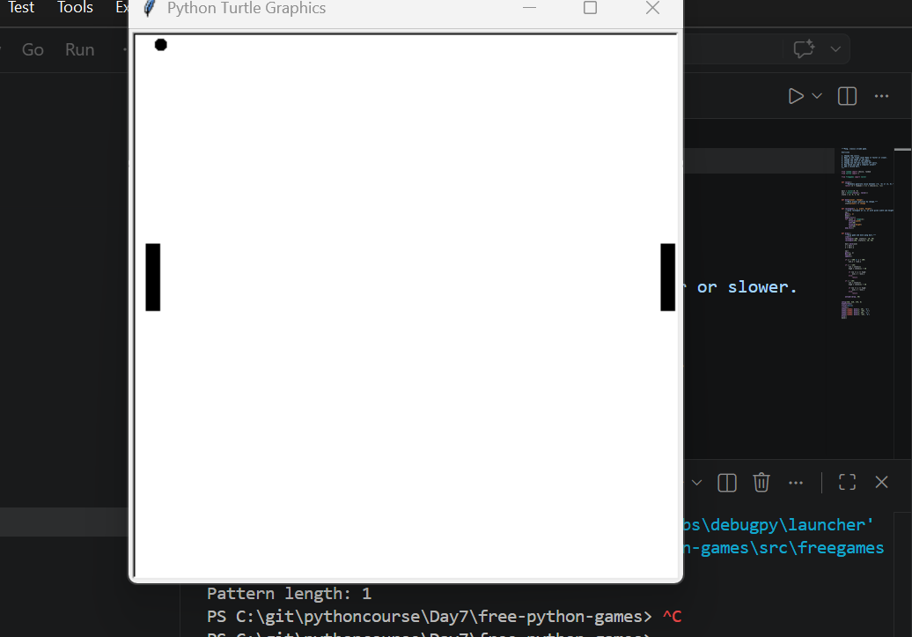
Pushing back to server using Tooling | I have been pushing back generally(with command line) as I go but to demo this function 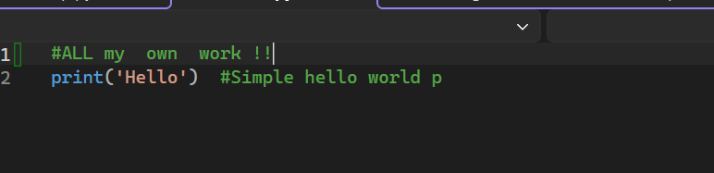  I made a small change shown above and committed back using GitHub Desktop 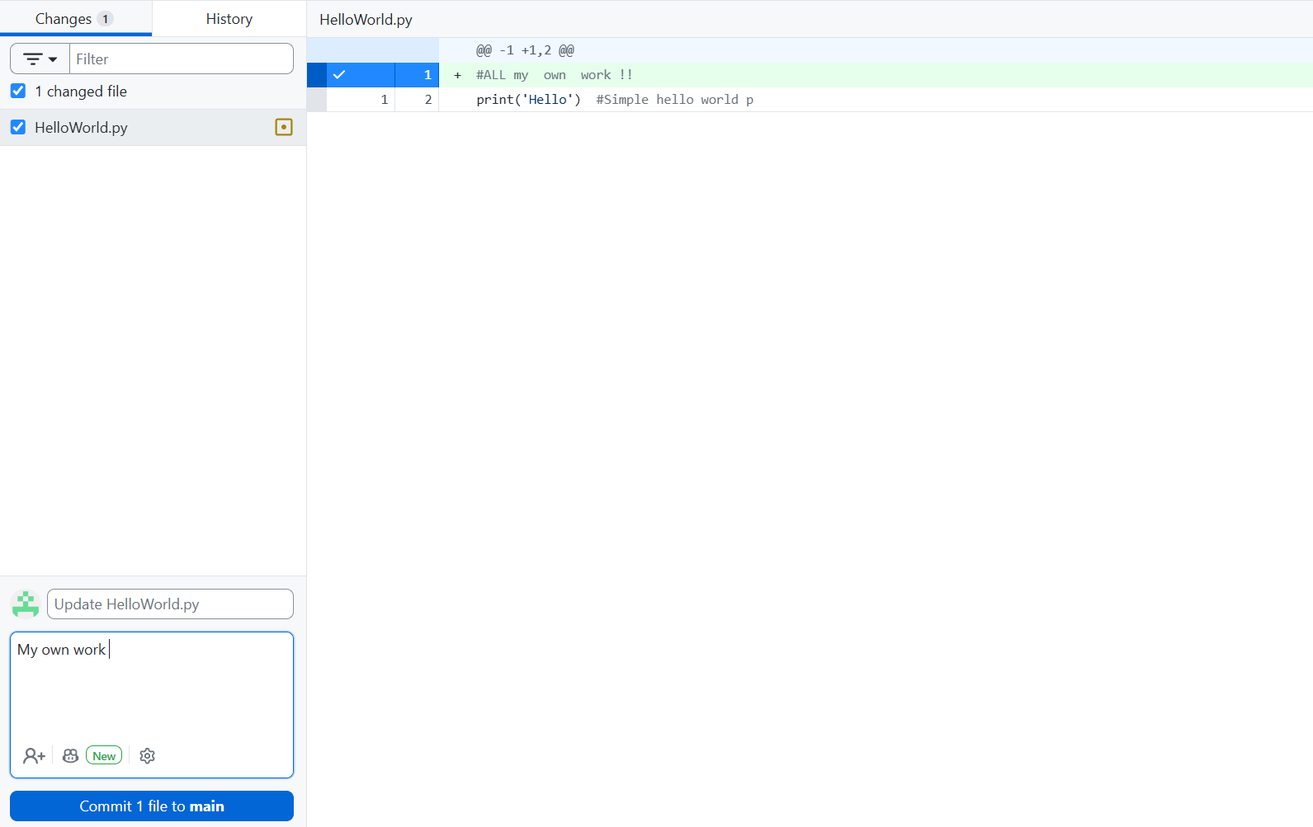  I then pushed back to origin with GitHub desktop with button below:  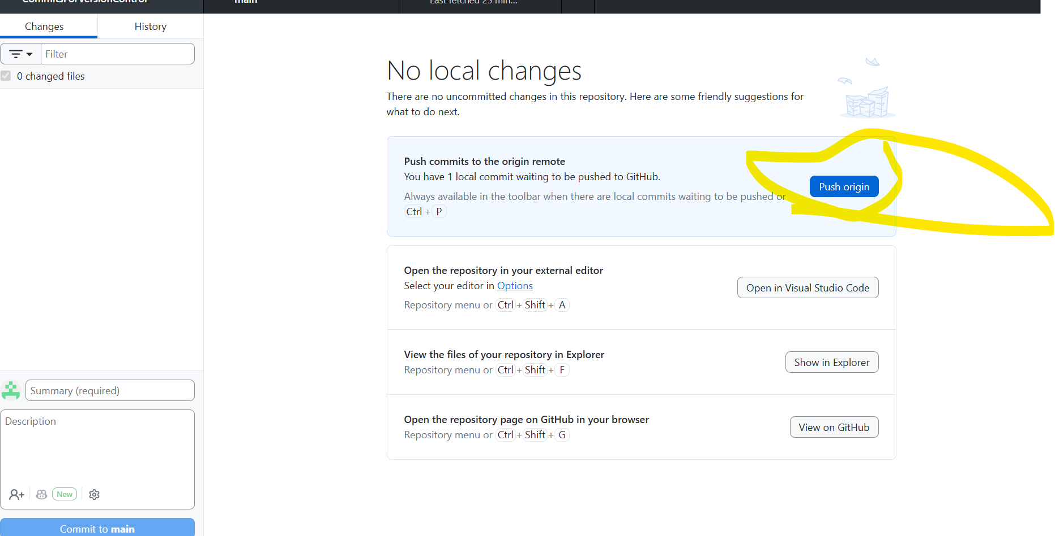  My most usual method of doing this kind of task however is using the Visual Studio tooling.The two screenshot below illustate this:  First commit :  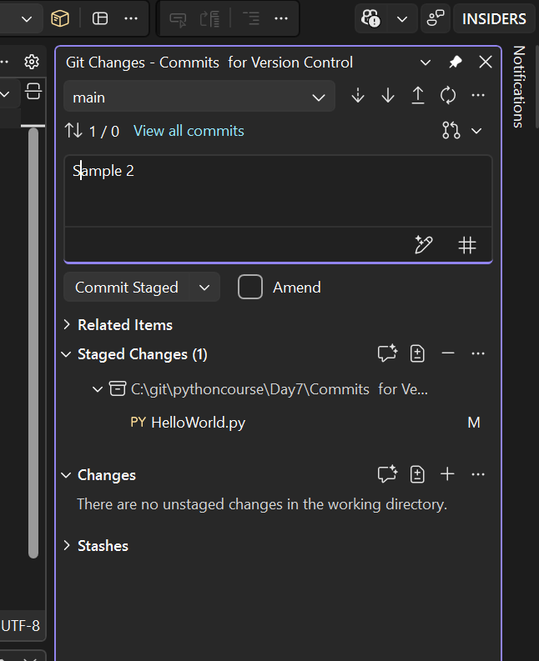  And then push:  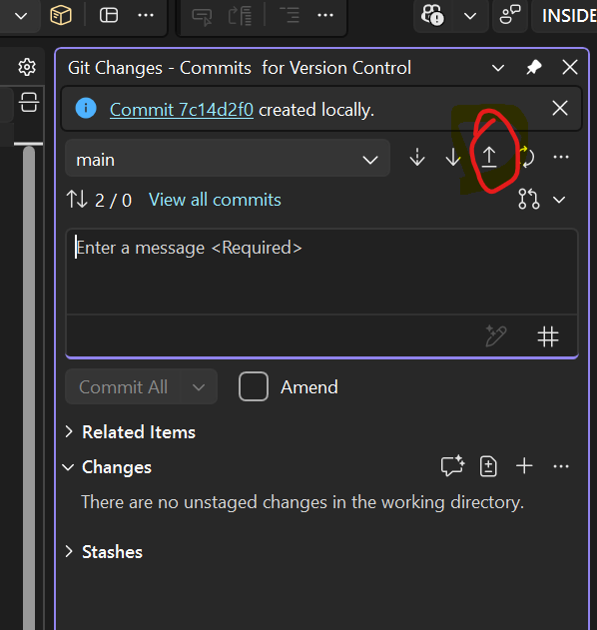  After doing this all commits are available and synced in the portal:  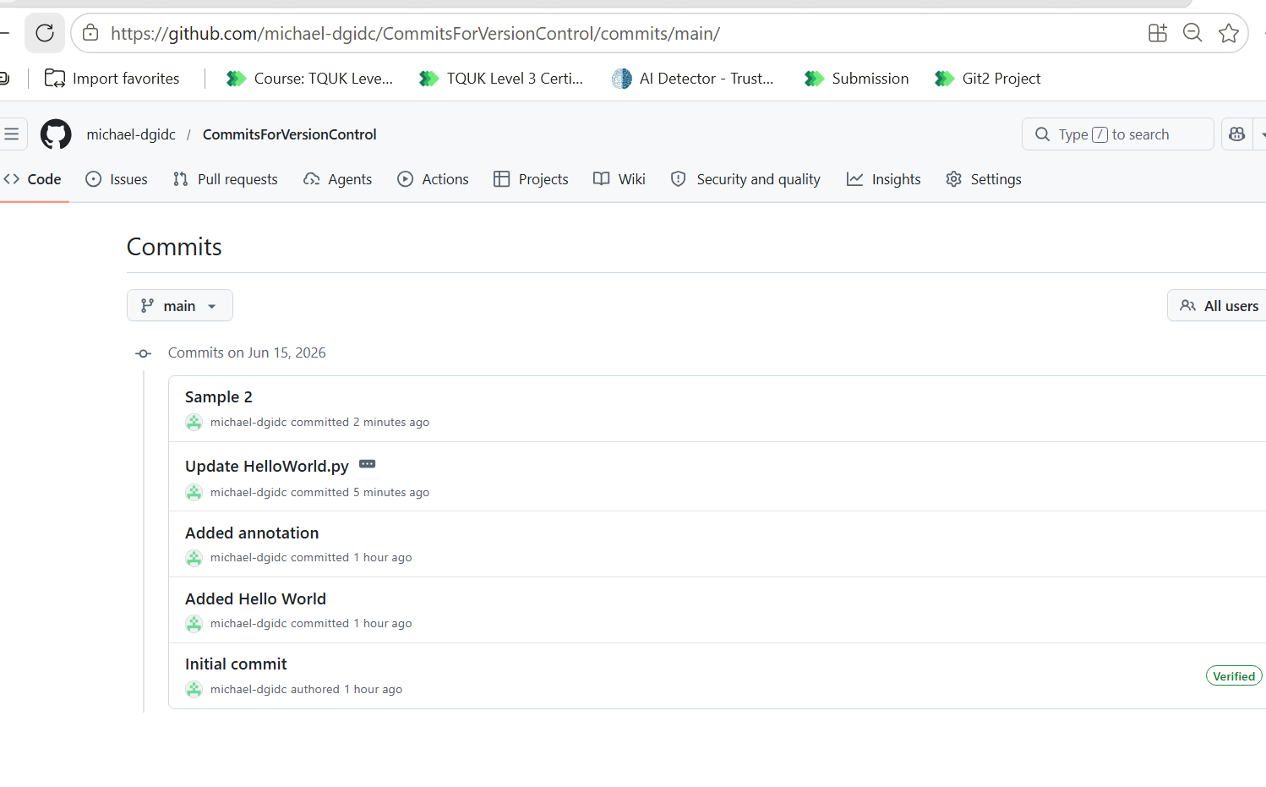

Delete commit
- Install git to device
- Open CMD and type cd C:\Users\MohammadAfgan\AppData\Local\Programs\Git
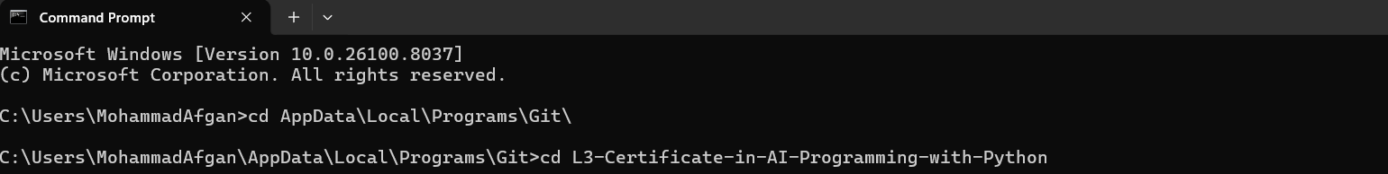
- Clone existing repositories to local machine. Log into GitHub.com, select repository and copy the URL e.g. https://github.com/Maafgan/L3-Certificate-in-AI-Programming-with-Python
- Type:- git clone https://github.com/Maafgan/L3-Certificate-in-AI-Programming-with-Python
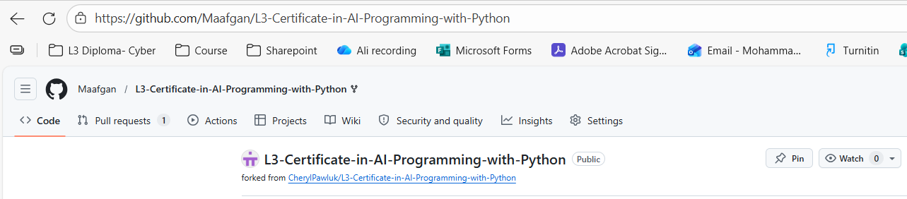
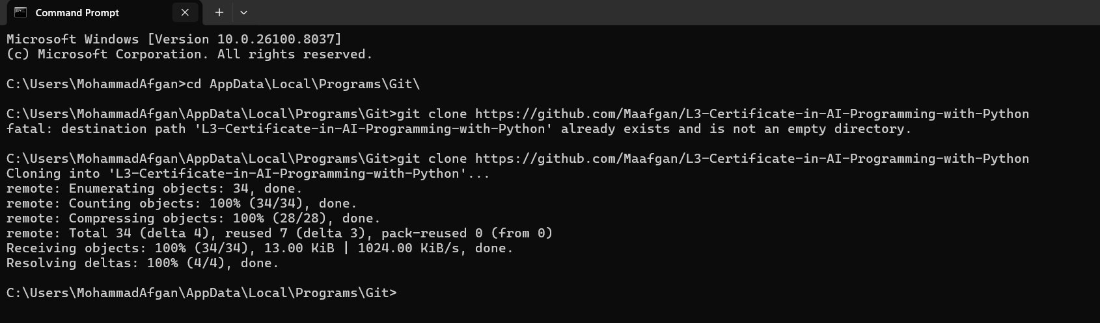

- Open the folder where the clone is copied to- type:- cd L3-Certificate-in-AI-Programming-with-Python

- Type:- git remote -v
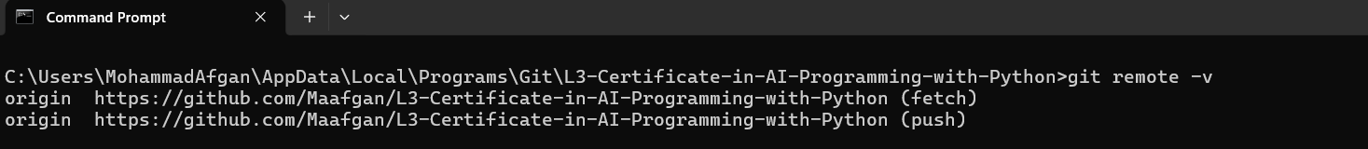

- Type:- git log
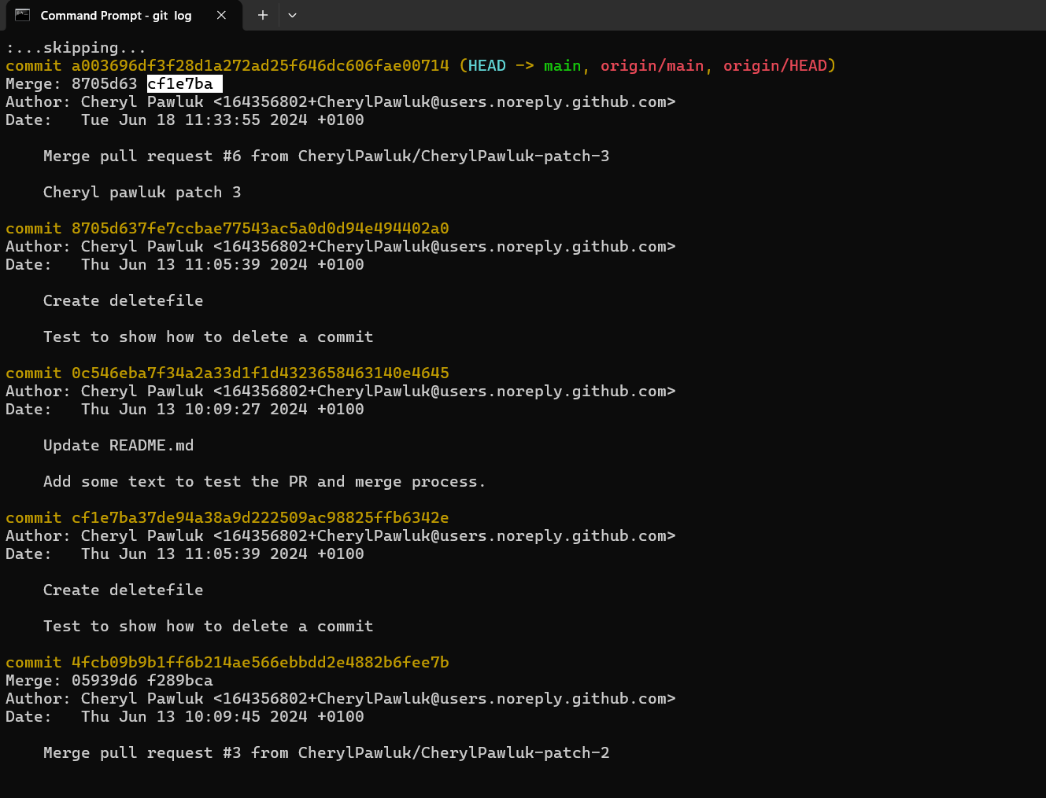

- Type:- git rebase -I HEAD~5
Change pick to drop
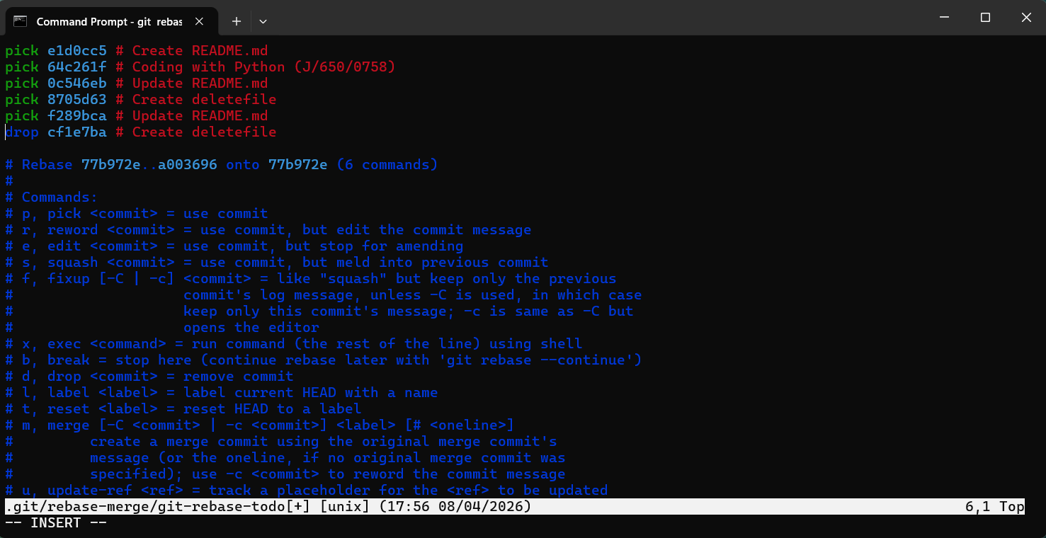

Then hold Control C then Type :wq
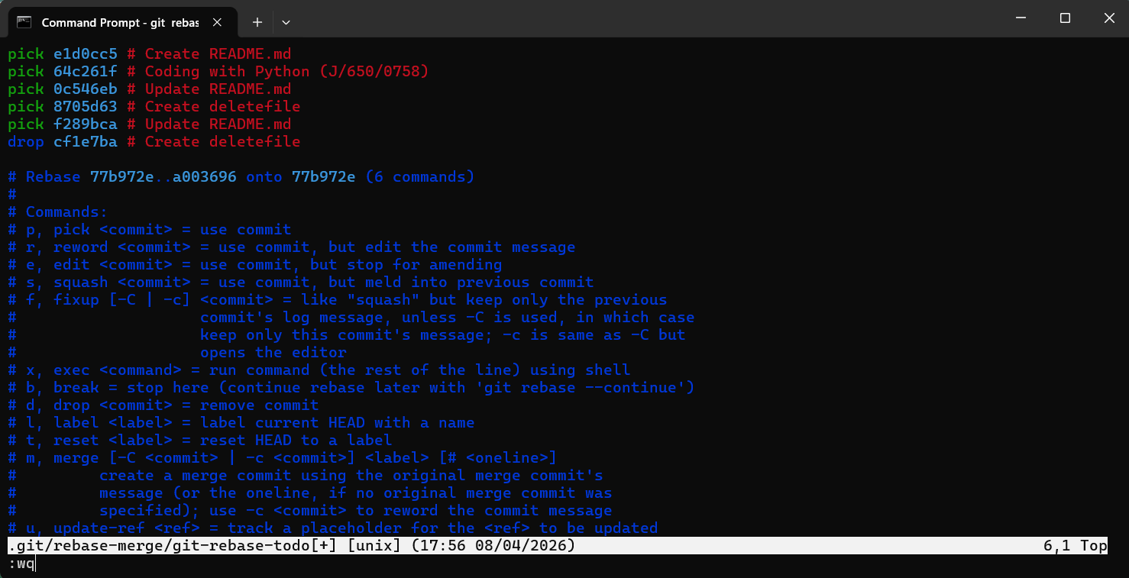
Press enter, you see the screen below.
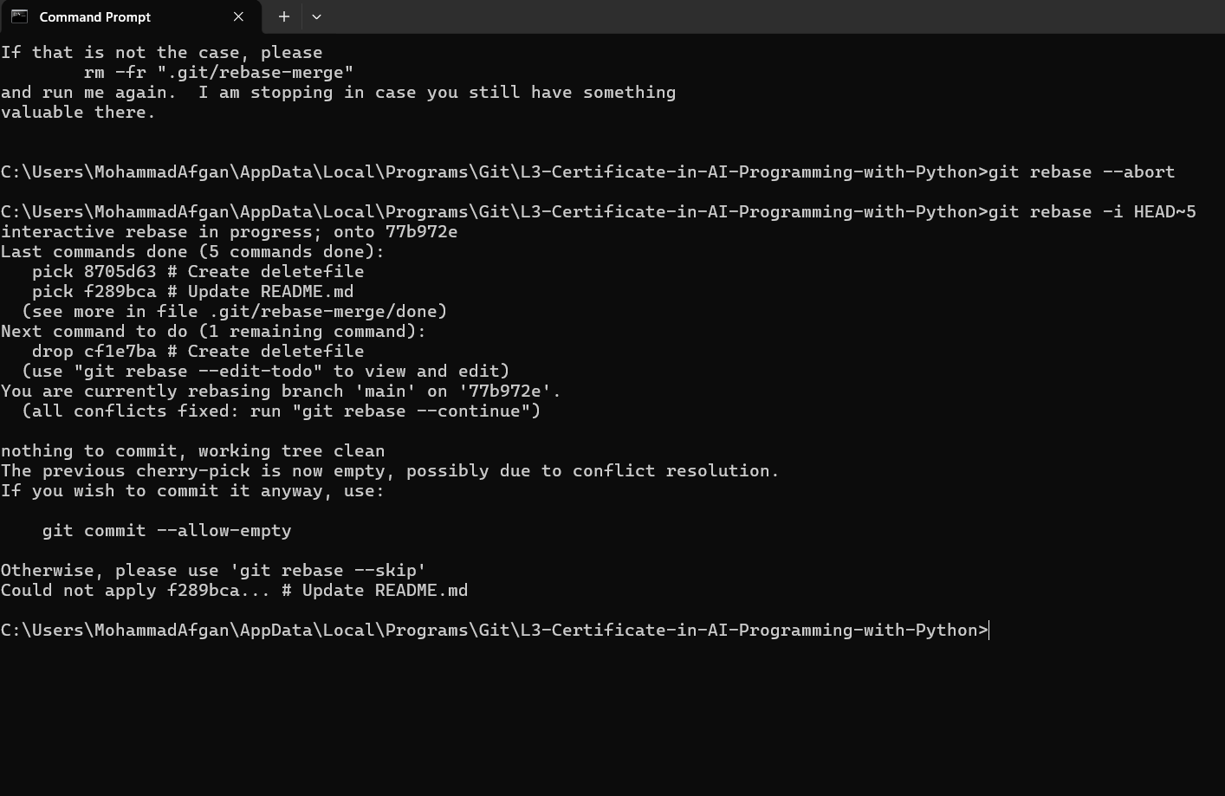
Type:- git commit --allow-empty

If error occurs type:- git push origin main --force
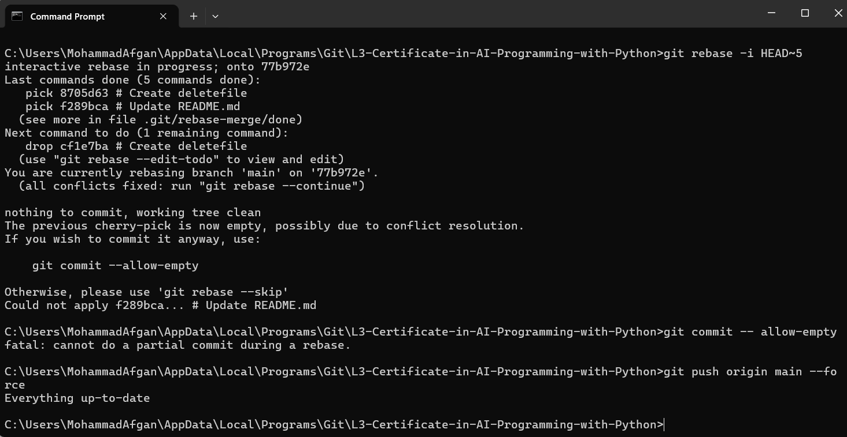
- Type:- git rebase – continue
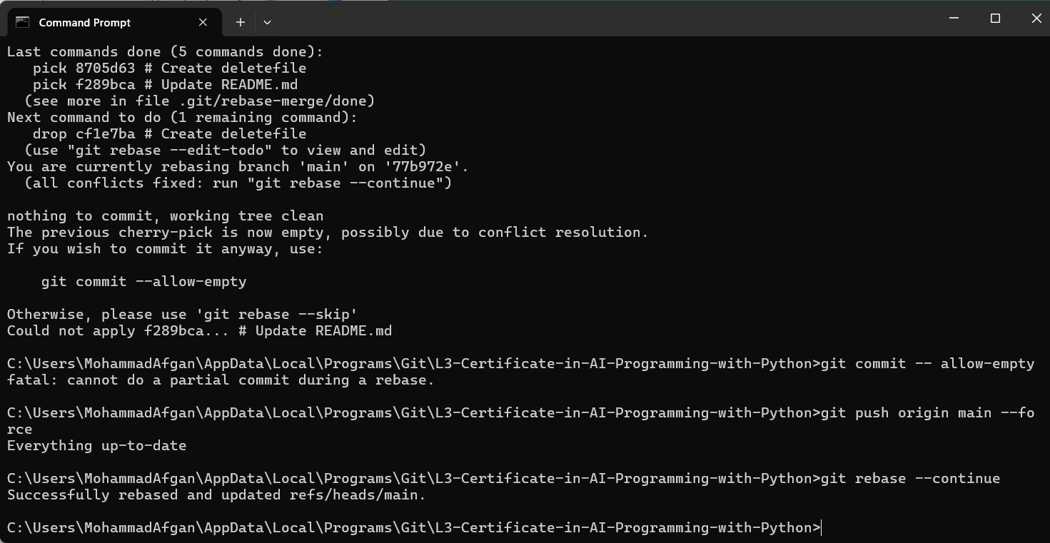
Successfully rebased and updated
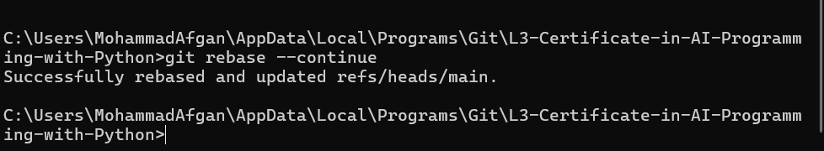

- Type:- git push origin main –force
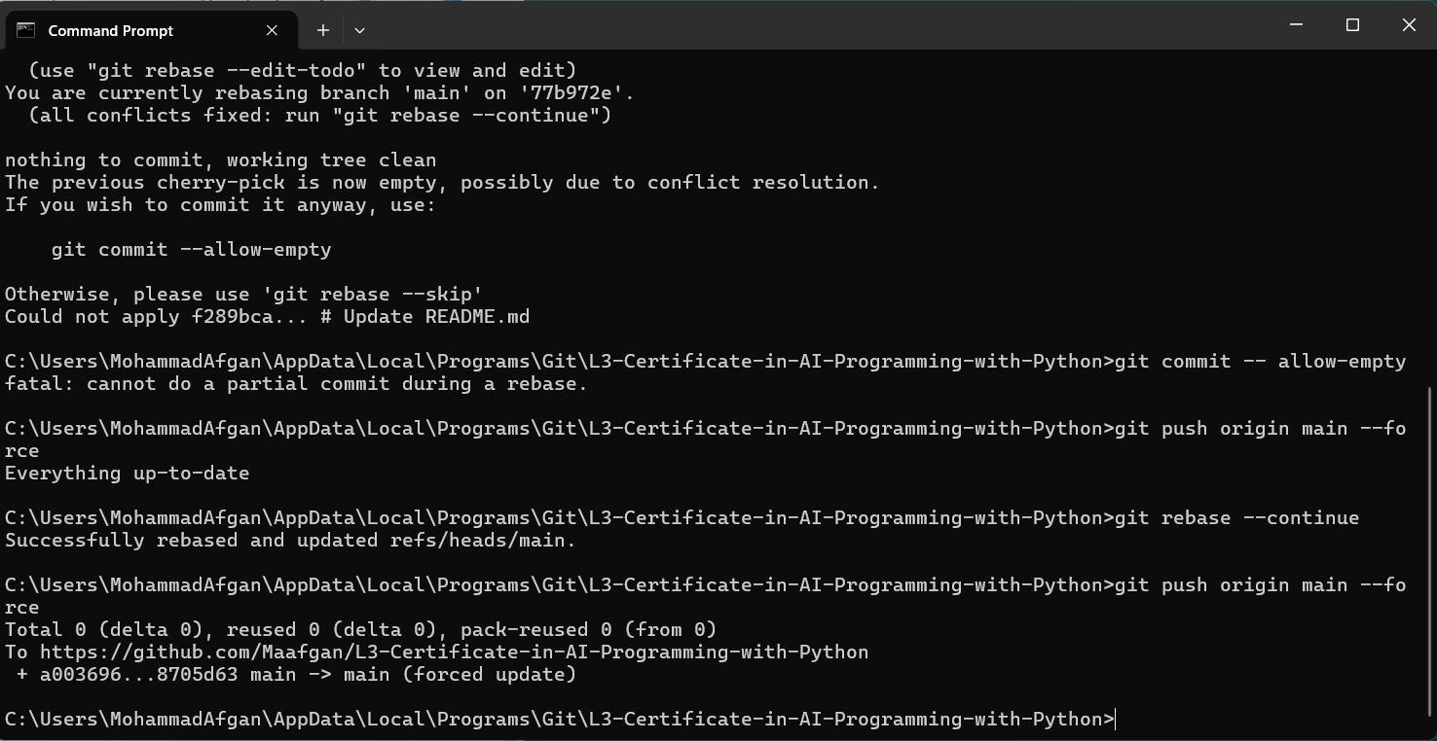
result
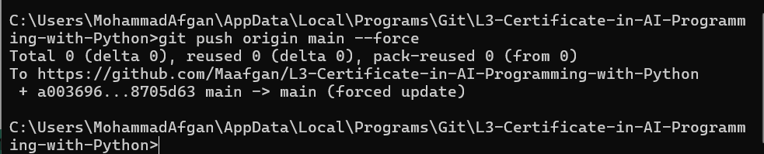

- Undo commit follow step 1- 6 then type:- git reset –hard HEAD~1
Another screenshot
